**Borwell Paint Project - Documentation**

**By Joshua Richardson-Noyes**

CONTENTS

**Creating a new Project:** **1**

Getting Started: 1

Setting Up: 2

Adding your first room element: 2

Additional Options: Automatically adding Walls: 2

**Resizing your Room Elements:** **3**

Switching to other elements in your room: 3

**Deleting A Room Element:** **3**

Selecting the Walls you want to Paint: 4

**Reading your Outputs:** **4**

The Lock Wall Heights Feature: 4

**Save and Load Features:** **5**

Saving your project 5

Opening your Project Later 5

Starting a new Project 5

**Final Comments:** **5**

## Creating a new Project:

Welcome to the Paint Project / Room Designer Program! It has been specifically designed to make working out how much paint you require to paint your room a whole lot easier. Not only will it calculate this for you, but it will also display a lot of other useful information such as the Volume of the room you have designed and the Surface Area of the Floor and Walls.

### Getting Started:

Almost as soon as you load up the program you will be immediately granted a blank canvas as a brand new project is loaded up straight away, making it quicker and easier to get started with your Room Designs. From this window you can now add new elements to your room, resize them to the sizes you want and get the information you need in no time! The rest of this documentation should help explain exactly how to use the program by guiding you through easily navigable sections.

### Setting Up:

Whilst the majority of the project is already set up for you, you may want to customize some things, such as the scale you work with before continuing on with your room design. If you look over to the top right corner of the window you will find the setup section. From here you can change the scale that you are working with simply by moving the provided slider towards the right for larger scales and towards the left for smaller scales.

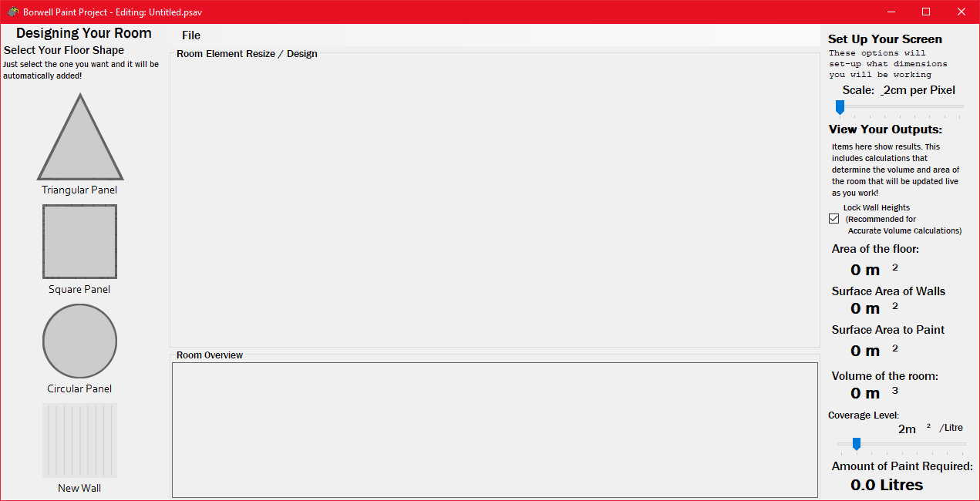

### Adding your first room element:

Now that setting things up are done and out of the way it’s time to add your first room element! If you look to the left side of the window you can see a list of objects that can be added to the room. The dark-gray objects are floor panels and then you have a wall panel at the bottom. Pick one that you would like to add, move your cursor over the object and simply left click it. It should automatically be added to the “your objects” overview panel at the bottom of the window and then appear in your Design View in the centre of the window. This action can be repeated with any element in the panel as many times as is necessary to create the room you would like to design.

### Additional Options: Automatically adding Walls for you:

After this, if you have chosen to add a floor panel, you will receive a pop-up dialog box asking you whether you would like to have the appropriate number of walls added to your selected floor shape. This is an optional extra that has been added to make the program simple to use. If you select yes the program will then proceed to add the appropriate number of walls. For example, if you have chosen a square it will add 4 walls. If you select no you will have to add the walls you wish to have in your room manually by selecting the ‘New Wall’ option in the elements list later.

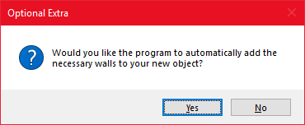

## Resizing your Room Elements:

Now that this is done, you should see your floor panel in the Design View at the centre of the window. From here you can resize your room object to whatever size you would like, and if it goes off the screen, don’t worry, simply change your scale slider accordingly so that it can fit with the dimensions you want to have on the element.

As shown in the screenshot above you should see the dimensions of the room element alongside the resize buttons, these can be clicked and dragged to change the size of the room element selected.

### Switching to other elements in your room:

So what if you want to resize another of the elements that have been added to your room? To keep things tidy on the window and to help you be able to better manage your room, each element in your room design is treated separate from the others giving you maximum workspace to resize your room elements. Have a look at the Room Overview Panel, located at the bottom of the window now. It should look something like this: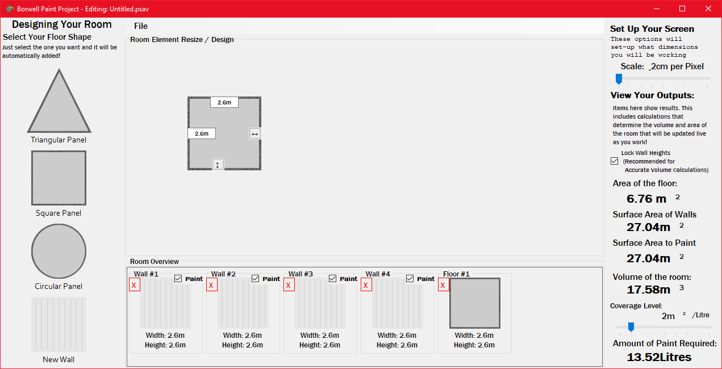

From here you can see each element that has been added to the room. It will show every wall and floor panel, accompanied by the dimensions of each underneath an icon sized image. If you’d like to resize another element in your room, simply click on the image or text of the room element you want to edit. This will immediately load that element into the workspace at the centre of your window and you can now resize the element as you wish. Furthermore, as you resize you will notice that the Width and Height values are updated almost immediately allowing you to easily see what element you are currently resizing.

## Deleting A Room Element:

Other options are also available in the Room Overview Panel. For all elements you are given a delete button, highlighted in Red. When clicked with the cursor you will be prompted to confirm that you want to delete the selected item. Should you select yes from this prompt, it will be immediately removed from the Design view (if currently open) and then from the Room Overview Panel.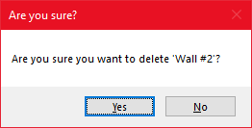

### Selecting the Walls you want to Paint:

Maybe you don’t want to paint every wall in your room? Perhaps a wall is already painted and you’re quite happy to keep that paint. That’s not a problem for this program! Also included in the Room Overview Panel is a checkbox that can be ticked / unticked accordingly on whether you want that wall painted or not. As soon as this option is ticked or unticked you should immediately see the calculations update accordingly and your Paint Required and Surface Area of Walls to Paint will update automatically!

## Reading your Outputs:

Whilst many of the readouts are fairly self-explanatory, it is still worth highlighting what each of these values mean and also to talk briefly about the handy slider that can be used to set the coverage that a paint type can cover. 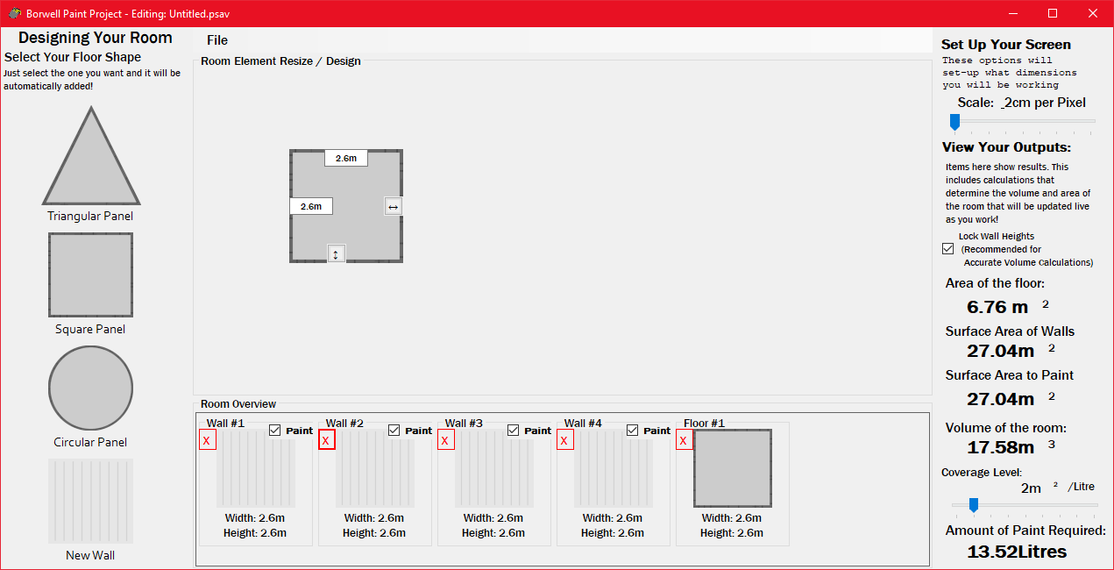

**Area of the floor** shows the total area that all of your floor elements combined make. Like with many of the other values it will automatically update as dimensions are changed, but only when modifying floor dimensions.

**Surface Area of Walls** shows the total surface area of all walls in your room design.

**Surface Area to Paint** shows the surface area of only the selected walls. it’s just the walls that you have checked in the Room Overview panel.

**Volume of the** **Room** calculates the overall volume of the room, but currently only supports rooms where all the walls have the same height, which is why there is a “lock walls” option described in more detail later in this document. After doing some research into a lot of the paint types that are out there, the tool now includes a slider that covers most of the values that the different paint types can cover. The slider can move from values as little as 1m2 of coverage per litre of paint, all the way up to a full 9m2 of coverage per litre.

**Amount of Paint Required** for the selected walls is then calculated and shown at the bottom right-hand corner.

### The Lock Wall Heights Feature:

One final item that can be seen on the right hand side of the screen, is the Lock Wall Heights checkbox. This is a feature that is enabled by default and allows for volume to be calculated correctly. When enabled it causes all of the walls in your room design to match each time you resize one of the wall elements. At the moment, for volume to be calculated correctly this must be on, as demonstrated by the warning message shown should you wish to disable it. Once again if you do choose to disable this feature you can do so simply by moving the mouse cursor over it and clicking.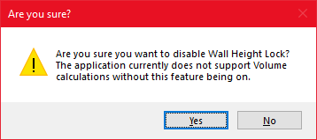

## Save and Load Features:

### Saving your project

Picture the scene, you’ve spent a number of minutes designing your room and you have to shutdown or restart your computer but you don’t want to lose your progress? Well, now you don’t have to. The tool also now comes with a Save and Load feature which can be accessed from the Context menu at the top of the window. Simply hit the “file” option then select “Save” and a save file window will appear allowing you to choose where you would like to save your project so you can continue working on it later. 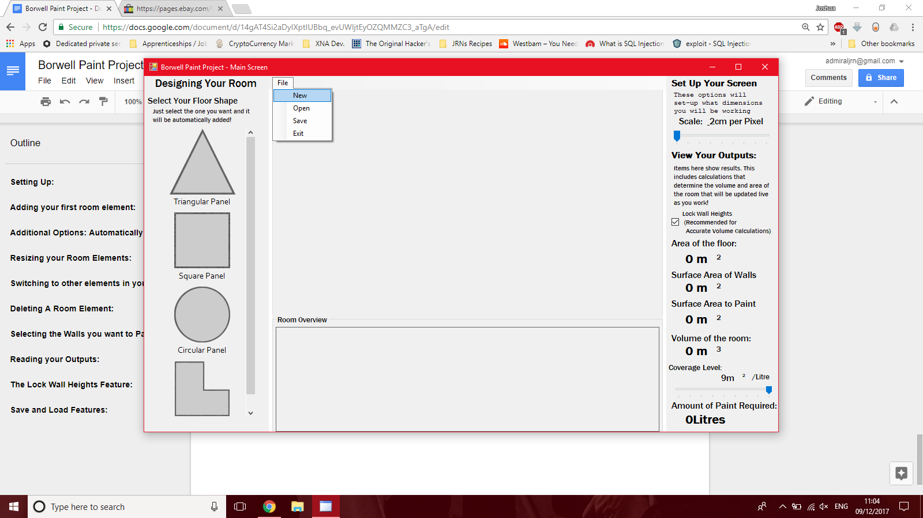

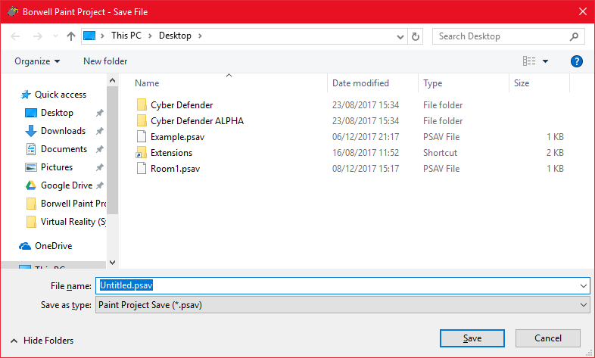

### Opening your Project Later

When you want to load your project up later, just load the program up again, hit the “file” option and select “open” from the dropdown menu. This will again open a window that you can use to navigate to your saved file and load up your project and continue as if you hadn’t closed the program at all!

### Starting a new Project

Another option in the “file” dropdown worth mentioning is also the New button. When clicked it will clear all panels for you and reset them to normal so that you can start working on a brand new project straight away without having to restart the application!

## Final Comments:

With all that laid out, hopefully that has now made using the tool a lot easier and you can get started figuring out just how much paint you need for all your walls. If you get stuck or would like to send me some feedback on the project, please feel free, I’d really like to hear what you think! My email address is: [admiraljrn@outlook.com](mailto:admiraljrn@outlook.com)